Name: _____________________ Class:__________ Date:__________
Instructions: Write answers in the right-hand column. Score: ___________ / 53 marks
Section A— Multiple choice (10 marks)

 | Tissues are found in multicellular organisms. Select the best definition of a tissue.  A A group of cells of the same type working together.  B Different organs working together to perform an important function.  C A number of different types of cells that make up an organ.  D Another name for a system. | A | 1
 | Explain how muscles attached to the bones move the body.  A by pushing and then pulling on the bone  B by contracting and pushing on the bone  C by contracting and pulling on the bone  D the muscles move automatically | C | 1
 | Describe peristalsis.  A the chewing of food in the mouth  B the contraction and relaxation of muscles that moves food through the digestive system  C the absorption of digested food into the bloodstream  D the removal of water from faeces in the large intestine | B | 1
 | Blocked arteries may cause a heart attack. Name the substance that causes the arteries to become narrow and then blocked.  A a fatty substance called cholesterol  B clumps of red blood cells  C white blood cells that are fighting infection  D food that was not digested properly | A | 1
 | Describe the function of a tendon.  A to join bones together at a joint  B to join muscles to bones  C to link muscles so they can work together  D to hold the compact and spongy bone together | B | 1
 | When humans take in more energy in their food than they need the excess is stored. Identify the form of this store of energy.  A glucose in the liver and muscles  B fat in the muscles and bones  C glucose surrounding internal organs  D fat as a layer under the skin | D | 1
 | Compare mechanical and chemical digestion.  A Chemical digestion breaks food down into smaller pieces. Mechanical digestion breaks complex molecules into simpler substances.  B Chemical and mechanical digestion both change complex foods into simpler substances.  C Mechanical digestion breaks food down into smaller pieces. Chemical digestion breaks complex molecules into simpler substances.  D Mechanical digestion only takes place in the mouth. Chemical digestion occurs in all other parts of the digestive system. | C | 1
 | The kidneys are the main organ of excretion. Other organs of the body are also involved. From this list identify the organ that is not involved in excretion.  A liver  B large intestine  C skin  D lungs | B | 1
 | Gastric juice is produced by special cells in the stomach wall. Identify the substance not found in gastric juice.  A mucus  B hydrochloric acid  C digestive chemicals  D bile | D | 1
 | 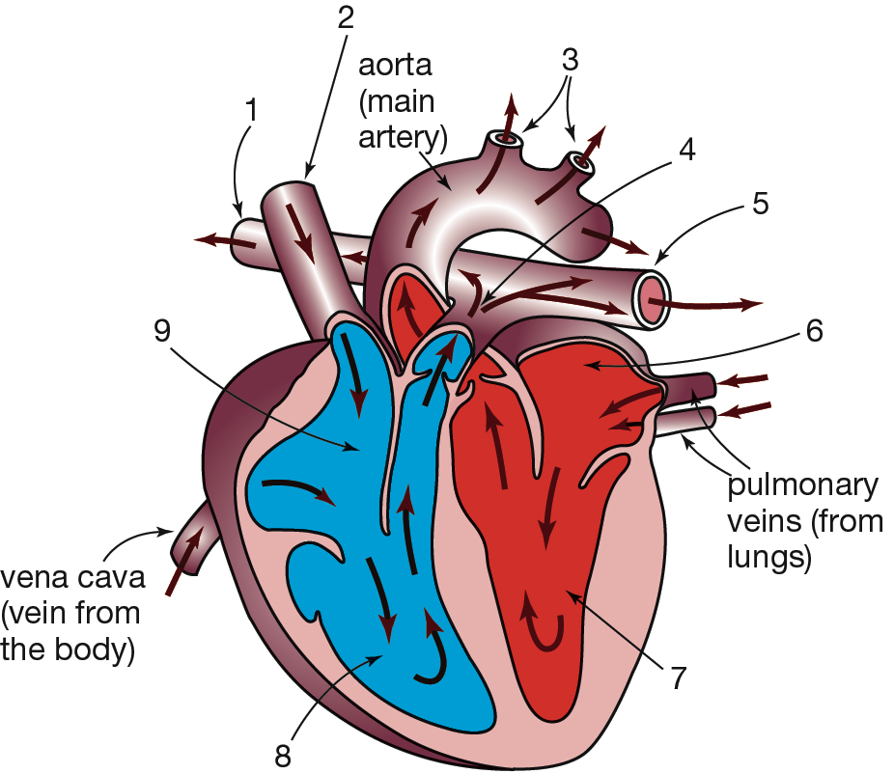  Use the information in this diagram of the human heart to identify the correct statement from the list below.  A Blood travels to the body from 3 and returns to the heart through 2.  B Blood travels to the body from 5 and returns into 6.  C Blood travels to both lungs from 5 and returns to the heart through 2.  D Blood travels to the lungs from 3 and returns into 9. | A | 1
Section B— Short answer (32 marks)
- ` | 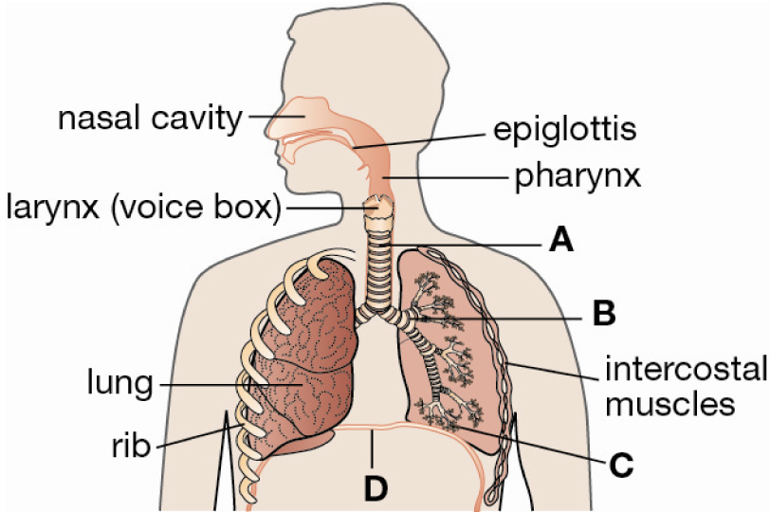  In this diagram of the human respiratory system, identify the labels A, B, C, and D. | A trachea  B bronchus  C alveoli  D diaphragm | 2
 | Recall the word equation that summarises respiration. | oxygen + glucose → carbon dioxide + water + energy | 2
 | Describe the changes that take place in your chest as you breathe in and out. | As you breathe in the muscles between the ribs contract pulling the rib cage up and out. The diaphragm contracts, pulling down. The volume of the chest cavity increases and air is sucked in through the nose and mouth.  The muscles between the ribs relax causing the ribs to move down and in. The diaphragm relaxes and arches up. The volume of the chest cavity decreases. Air is forced out of the lungs through the nose and mouth. | 4
 | The human circulatory system is made up of the heart, blood and blood vessels. Briefly describe the role of each of these parts. | The heart pumps blood to all parts of the body. In the lungs, oxygen is collected by the red blood cells in the blood, and waste carbon dioxide passes from the blood into the lungs. Blood carries dissolved nutrients to, and wastes away from, body cells. It contains white blood cells for fighting disease, and platelets to clot blood during bleeding injuries. Blood vessels are the tubes that carry the blood. While some carry blood that is rich in oxygen and other nutrients to the body cells, others carry the blood that carries waste materials away from body cells. | 4
 | Explain the difference between mechanical and chemical digestion, giving one example of each. | Mechanical digestion involves food particles being physically broken down into smaller particles. For example, teeth mechanically digest food in the mouth, and the stomach churns food. Chemical digestion involves complex food molecules being broken down into simpler molecules by digestive juices that contain enzymes. For example, digestive enzymes in saliva break starch down to simple sugars; chemicals in the stomach break proteins down into simpler molecules (amino acids); and chemicals from the pancreas reduce fats and oils to simpler molecules (fatty acids and glycerol) and complete the digestion of carbohydrates and proteins. | 2
 | 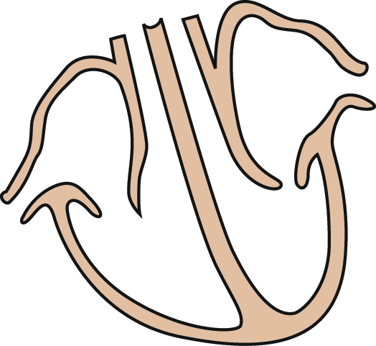  a On the diagram shown above, name the main blood vessels entering and leaving the heart.  b State where the blood is coming from or going to.  c Use arrows to indicate the direction of blood flow.  d Use red and blue pencils to colour the heart chambers, using red to represent oxygenated blood and blue to represent deoxygenated blood (that is, lacking oxygen). | a See diagram below.  b See diagram below.  c See diagram below.  d The left side of heart (the right side as you look at the diagram)—the left atrium and ventricle would be coloured red; the right side of heart (the left side as you look at the diagram)—the right atrium and ventricle would be coloured blue.  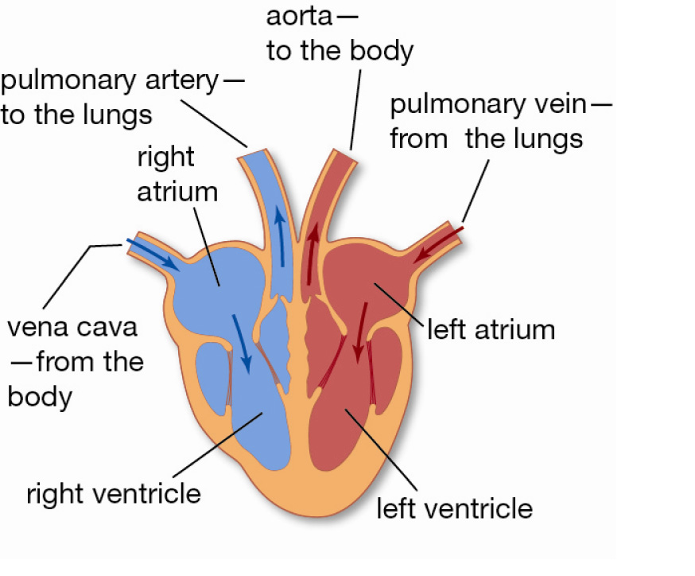 | 5
 | The human circulatory system is referred to as a double system.  a Explain what is meant by a double system.  b Describe the difference between the blood that is pumped to the lungs and the blood that is pumped to the rest of the body.  c Explain the advantage of blood being pumped separately to the lungs. | a There are two separate circuits through which the blood flows. One is from the heart to the lungs and back to the heart. The other is from the heart to the body and back to the heart.  b Blood that is pumped to the lungs has just returned from circulating through the body. It is rich in carbon dioxide and has very little oxygen. Blood that is pumped to the rest of the body has just returned to the heart from the lungs, so it is rich in oxygen and low in carbon dioxide.  c Having two separate circuits means that the blood rich in oxygen and the blood lacking in oxygen are not mixed. This means that delivery of oxygen to the cells is more efficient. | 3
 | Compare the axial skeleton and the appendicular skeleton. Discuss the differences. | The axial skeleton is made up of 80 bones. Its role is protection of body organs. The axial skeleton includes your skull (that protects your brain), vertebral column (that protects your spinal cord), and ribs and breastbone (that protect your lungs and heart).  The appendicular skeleton is made up of 126 bones. Its role is to allow movement of the body. The bones of the appendicular skeleton include your shoulder blades and the bones in your arms and legs. | 4
 | Describe the function of the following parts of a joint in the skeleton.  a cartilage  b synovial fluid  c ligaments | a Cartilage (or gristle) is a smooth and slippery tissue that covers the ends of bones. It allows bones to move easily against each other.  b Synovial fluid is within the joint. It lubricates the bone ends and allows them to slide over each other freely.  c Ligaments are bands of tough, flexible tissue that hold the bones in a joint together and prevent the bones of the joint from moving too far. | 3
 | Describe the main functions of the kidneys. | The kidneys:  • excrete urea.  • control the level of water in the body.  • control salt levels in the blood. | 3

Section C— Thinking scientifically (10 marks)

 | John and David each eat a banana, which provides each of them with 320 kJ of energy. John then goes for a run, which uses 40 kJ of energy per minute. David goes back to work, which involves sitting and standing and uses 8 kJ each minute. Calculate how much longer it takes David to use up the energy supplied by his banana than it takes John.  A 8 minutes  B 32 minutes  C 40 minutes  D 48 minutes | B | 1
 | All living things carry out the process of respiration, which provides them with the energy they require. Plants also carry out photosynthesis, a process that uses energy from the Sun to produce stored energy in the form of glucose. These processes can be represented by equations:  Respiration: glucose + oxygen → carbon dioxide + water + energy  Photosynthesis: carbon dioxide + water 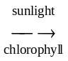 glucose + oxygen  Identify the true statement. All living things:  A produce glucose and oxygen.  B use carbon dioxide and water.  C produce carbon dioxide and water.  D require sunlight to produce energy. | C | 1
 | 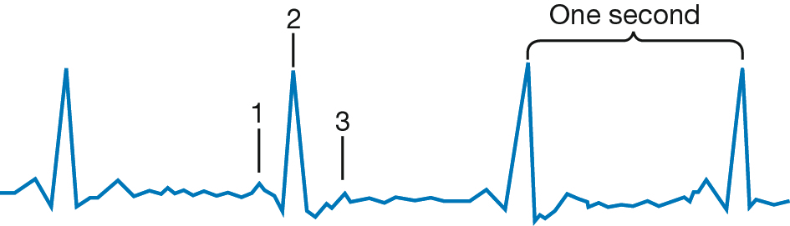  This diagram represents an electron recording of a heart beating. Interpret this diagram.  A It takes one second for the ventricles to contract.  B Label 1 is the contraction of the ventricles, label 2 is the contraction of the atria and the heart takes one second to complete one beat.  C Label 1 is the contraction of the atria, label 2 is the contraction of the ventricles and the heart is beating 60 times a minute.  D Labels 1 and 3 indicate the contraction of the atria and label 2 indicates the contraction of the ventricles. | C | 1
 | Many birds have hollow bones. Propose a reason for this.  A Many birds are very small therefore they do not need solid bones.  B Hollow bones are lighter therefore less energy is needed when flying.  C Hollow bones are stronger than solid bones and can withstand the stresses of flying.  D Birds do not have much calcium in their diet and therefore cannot produce solid bones. | B | 1
 | The kidneys filter about 180 L of blood every day. The average human has about 5 L of blood. Calculate the number of times each litre of blood passes through the kidneys in a day.  A 36 times  B 175 times  C 185 times  D 900 times | A | 1
 | 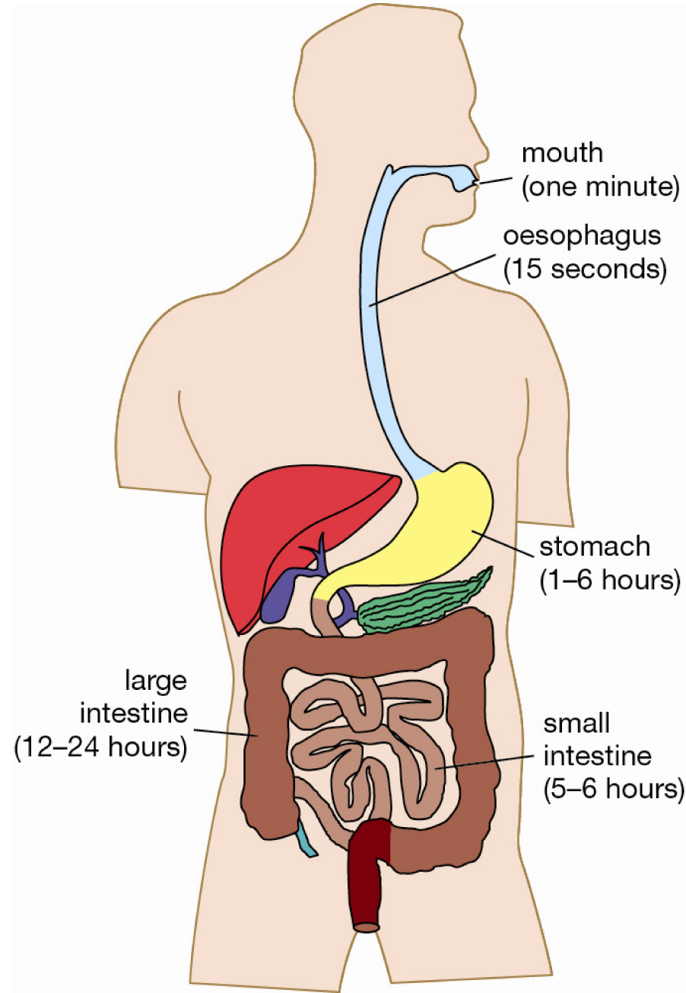  The diagram shows the parts of the digestive system and the time food spends in each part.  Calculate the minimum and maximum amount of time a piece of food would remain in the digestive system.  A Min: 24 hours 1 minute and 15 seconds. Max: 30 hours 1 minute and 15 seconds  B Min: 24 hours 1 minute and 15 seconds. Max: 31 hours 1 minute and 15 seconds  C Min: 18 hours 1 minute and 15 seconds. Max: 24 hours 1 minute and 15 seconds  D Min: 18 hours 1 minute and 15 seconds. Max: 36 hours 1 minute and 15 seconds | D | 1
 | Using the diagram in question 6, deduce the changes that could occur in the digestive process.  A Food is likely to remain longer than 24 hours in the large intestine of a person suffering from diarrhoea.  B Food is likely to remain less than 12 hours in the large intestine of a person suffering from constipation.  C Food would spend only a short time in the small intestine if a person vomited.  D Food would pass through the small and large intestines in much less than 17 hours if a person had diarrhoea | D | 1
 | 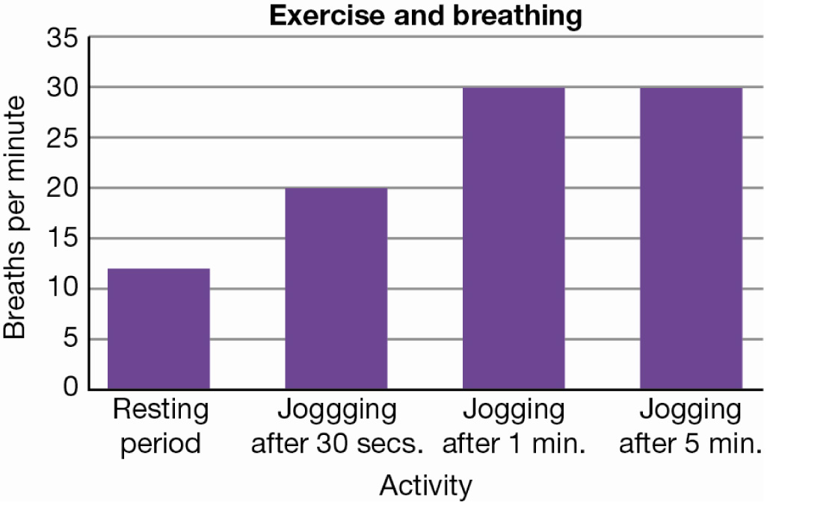  This graph shows that the breathing rate increases when you start exercising but that it does not necessarily continue to increase as you continue to exercise. Identify the statement that cannot explain the data in the graph.  A As you start to exercise, your breathing rate increases because you need more oxygen for your muscles to work.  B Physical activity produces more carbon dioxide in your body and you have to get rid of it.  C When you do a lot of exercise you breathe more deeply and you do not have to breathe as often.  D When you are exercising at a constant rate your breathing rate becomes constant. | C | 1
 | 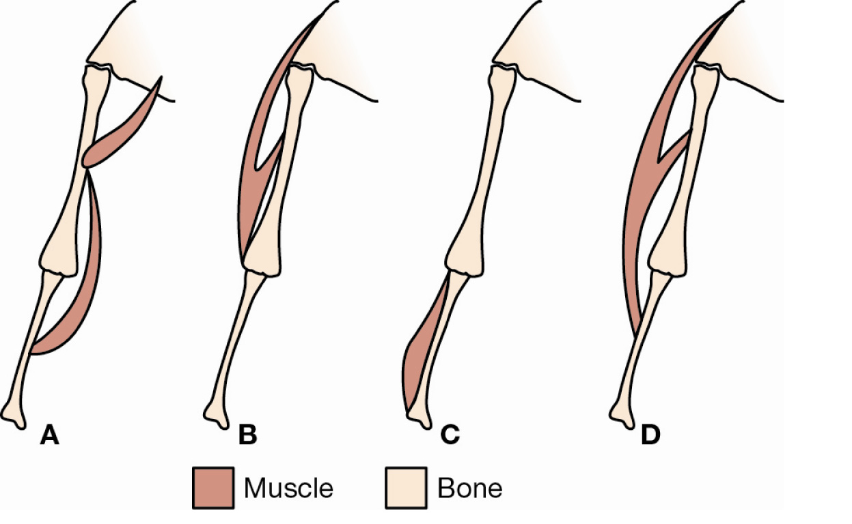  Deduce which arrangement of muscles would cause the arm to bend at the elbow.  A  B  C  D | D | 1
 | Use the diagram of the heart to answer the following.  Deduce the incorrect statement.  A Blood is forced out of 7 and 8 under equal pressure.  B Blood in 3 is under greater pressure than in 6.  C Valves allow blood to leave the heart but not re-enter the heart.  D Blood in 3 travels a greater distance before returning to the heart than blood in 5. | A | 1

